Expt 5 Date: /09/2026
Prim’s Minimum Cost Spanning Tree.

Aim: Implement Prim’s Minimum Cost Spanning Tree.
Theory:
Let G = (V, E) be an undirected connected graph. A sub-graph t = (V, E’) of G is a spanning tree of G if and only if‘t’ is a tree.
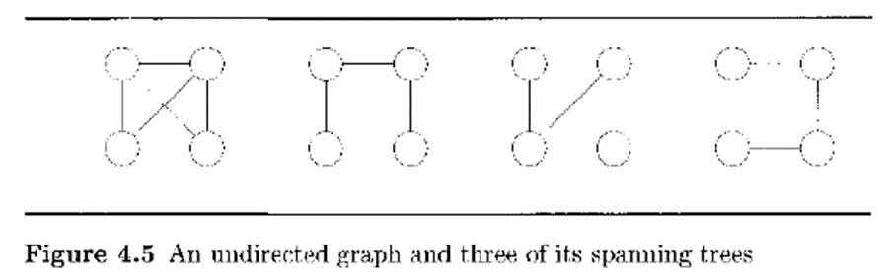
Spanning trees can be used to obtain an independent set of circuit equations for an electric network. If the ‘n’ nodes of G represent cities and the edges represent possible communication links connecting two cities, then the minimum number of links needed to connect the ‘n’ cities is n-1. The spanning-trees of G represent all feasible choices.
In practical situations, the edges have weights assigned to them. These weights may represent the cost of construction, the length of the link, and so on. Given such a weighted graph, one would then wish to select cities to have minimum total cost or minimum total length. In either case, the links selected must form a tree (assuming all weights are positive). If this is not so, then the selection of links contains a cycle. Removal of any one of the links on this cycle results in a link selection of less cost connecting all cities. We are therefore interested in finding a spanning tree of G with minimum cost. (The cost of a spanning tree is the sum of the costs of the edges in that tree.)
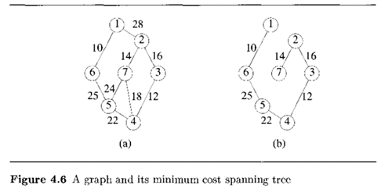
Since the identification of a minimum-cost spanning tree involves the selection of a subset of the edges, this problem fits the subset paradigm.
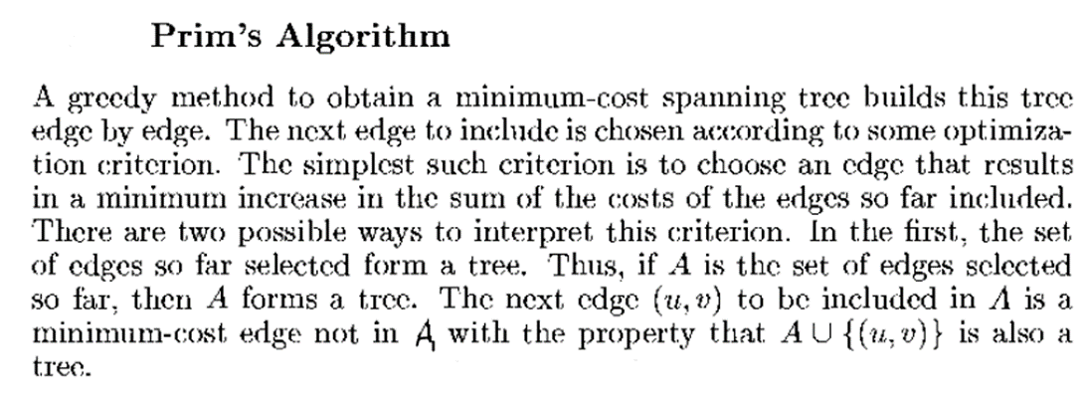
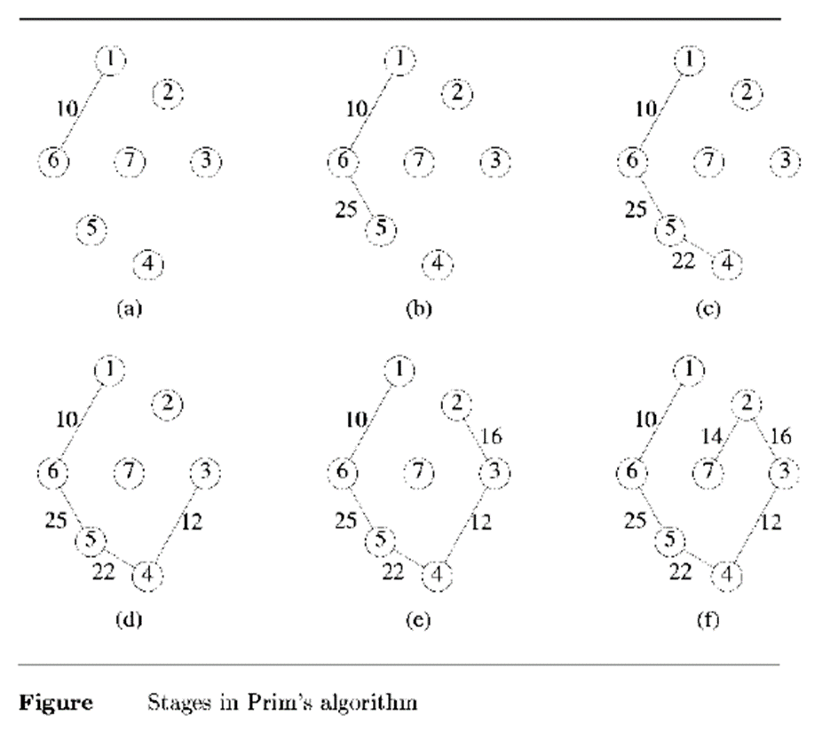

Algorithm:
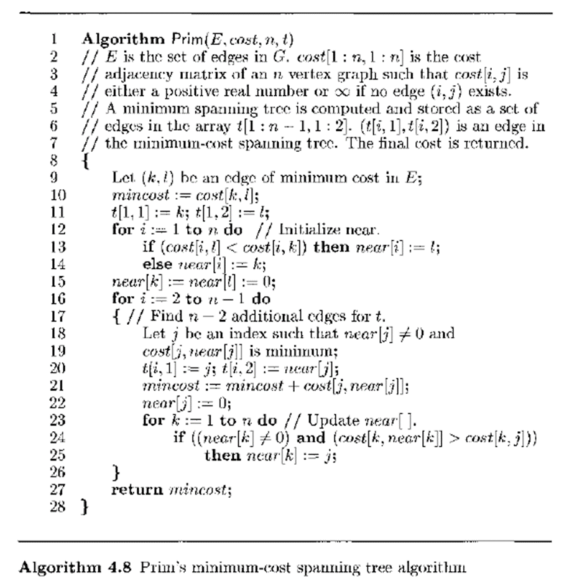

Prim’s algorithm for the graph[7][7], |V| = 7
Initialize the cost adjacency matrix
int graph[V][V] = {
// 0 1 2 3 4 5 6
{ INT_MAX, 28, INT_MAX, INT_MAX, INT_MAX, 10, INT_MAX },//0
{ 28, INT_MAX, 16, INT_MAX, INT_MAX, INT_MAX, 14},//1
{ INT_MAX, 16, INT_MAX, 12, INT_MAX, INT_MAX, INT_MAX },//2
{ INT_MAX, INT_MAX, 12, INT_MAX, 22, INT_MAX, 18 },//3
{ INT_MAX, INT_MAX, INT_MAX, 22, INT_MAX, 25, 24},//4
{ 10, INT_MAX, INT_MAX, INT_MAX, 25, INT_MAX, INT_MAX},//5
{ INT_MAX, 14, INT_MAX, 18, 24, INT_MAX, INT_MAX }//6 };

Step 1: Find the edge with the least cost (k, l).
Step 2: mincost = graph[k][l]
Step 3: Store (k, l) in the spanning tree t[V][2].
t[0][0] = k, t[0][1] = l
Step 4: Initialize near
for (int i = 0; i < n; i++) {
if (graph[i][l] < graph [i][k])
near[i] = l;
else
near[i] = k; }
Step 5: Reset near for the included edge
near[k] = near[l] = -1;

Step 6: Find the n-2 additional edges for t
for (int i = 1; i < n-1 ; i++){
//Find j such that near[j] ≠ -1 and edge cost is least
int min = INT_MAX;
int j = 0;
for (int v = 0; v < n; v++) {
if (near[v] != -1 && graph[v][near[v]] < min){
min = c[v][near[v]];
j = v; } }
//Store the edge (j, near[j]) in t
t[i][0] = j;
t[i][1] = near[j];
//Update mincost and reset near[j]
mincost += c[j][near[j]];
near[j] = -1;
//update near
for (int k = 0;k < n;k++) {
if (near[k] != -1 && c[k][near[k]] > c[k][j])
near[k] = j; } }

Step 7: Return mincost. Print t and mincost.

Task : Write programs to implement Prim’s algorithms.
.

Code:

Output:

Conclusion:

